新北市立三多國民中學 110學年度第二學期 第二次段考 九年級 英語科試題卷

答案請劃記至答案卡上，共50題
第壹部分 聽力測驗
(第1-15題，每題2分，共30分)
- 根據聽到的內容，選出符合描述的圖片或符合圖片的描述。
1.
(A) ) 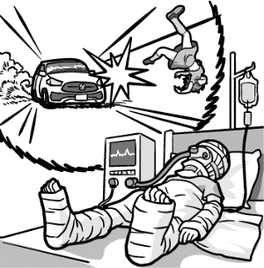 | (B)  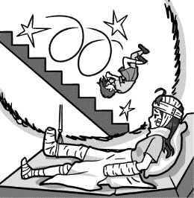 | (C)  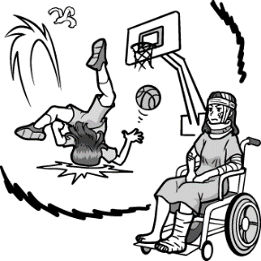
2.
(A) 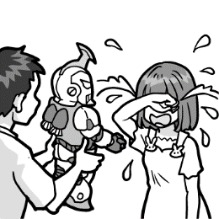 | (B)  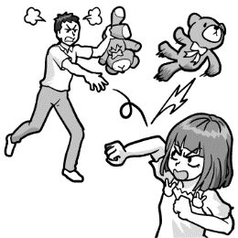 | (C)  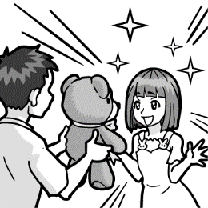
3.
(A) 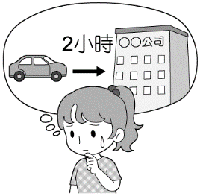 | (B)  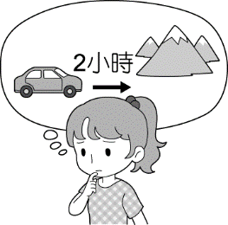 | (C) 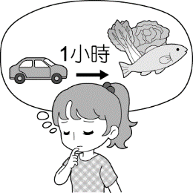
4.
(A)  | (B)  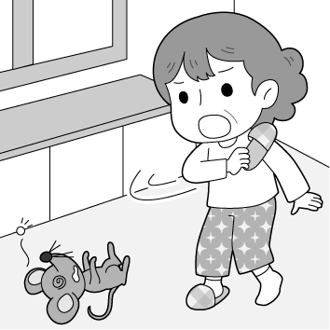 | (C) 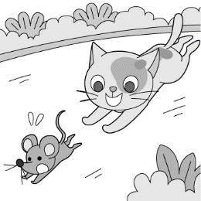
5.
(A) 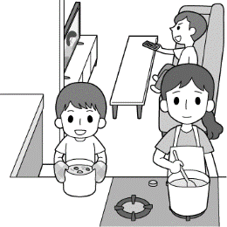 | (B)  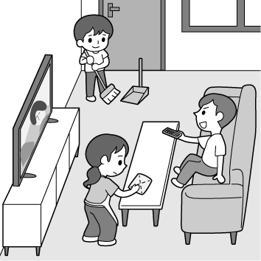 | (C)  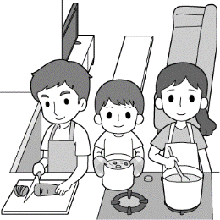

- 根據聽到的內容，選出一個最適合的回應或最適合的問句。
6.
(A) I stayed up late last night to prepare for today’s English test.
(B) Oh, I’ll wash my face later.
(C) I need to turn on the light because the room is so dark.
7.
(A) I can’t agree with you anymore. She is really good at English.
(B) No wonder she likes to exercise a lot.
(C) We had better look up the words in the dictionary.

8. P.1
(A) She won’t hand in their homework until tomorrow.
(B) Next week. We are going to Green Island for a week.
(C) No, she came back from Chicago last month.
9.
(A) I can’t tell what they are.
(B) There are so many animals in the zoo.
(C) I don’t know. Let’s look it up on the Internet.
10.
(A) Yes, I often surf the Internet to look for some information.
(B) Yes, I’ll take your order in a minute.
(C) Sure. I’m happy to help you. It’s very easy.

- 根據聽到的內容，選出一個最適合的答案。
11.
(A)The man who is taking pictures lost his wallet.
(B) The man with green hair lost his wallet.
(C) The man that is talking on the cellphone lost his wallet.
12.
(A) He is tall and has short brown hair.
(B) He comes to Taiwan for traveling.
(C) He comes to Taiwan once a year.
13.
(A) She was watching a TV show about science.
(B) She had a toothache.
(C) She was preparing for a test.
14.
(A) Come to her place to finish the science report.
(B) Take science classes this afternoon.
(C) If he sees Leo tomorrow, ask him to call her.
15.
(A) Some food is good for their health.
(B) Some good ways and tips to learn English.
(C) Some people like to listen to the radio in their free time.

第貳部分 讀寫選擇 (共50分)
一、單題 (第16-35題，每題2分，共40分)
16. Look at that picture. The man is ＿＿＿ the mouse.
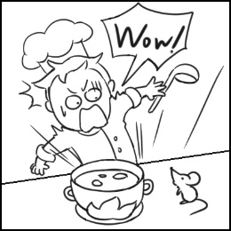
(A) tired of (B) interested in
(C) excited about (D) scared of

17.Larry was sad that the girl he likes didn’t ______ to
his birthday party.
(A) stay up | (B) knock out
(C) point out | (D) show up
18. The past is gone and the future hasn’t come yet; just live in
the ______ .
(A) present (B) alphabet (C) mission (D) speed

19.Excuse me, sir. Would you ______ changing seats with me ?
I need to take care of my children.
(A) raise (B) pick (C) encourage (D) mind
20.The new cellphone is ______ expensive ______ the tablet computer(平板電腦).
(A) much ; than (B) as ; as
(C) too ; to (D) much ; than
21. Mr. Wang looked ______ because his son did ______ on the
test.
(A) angrily ; badly (B) angry ; bad
(C) unhappy ; badly (D) not happily ; worse
22. _______ have much snow in January in New York.
(A) There (B) It (C) These (D) We
23. The planet ______ we live is called Earth.
(A) where (B) which (C) in who (D) on that
24. If the weather is fine this weekend, my family ______ to
Tainan for two days.
(A) go (B) went (C) will go (D) have gone
25. I remember ______ Selina where to meet us. I don’t know
why she didn’t appear.
(A) to tell (B) telling (C) told (D) tell
26. Kevin can’t find his wallet. It might have _________ .
(A) be stolen (B) been stolen
(C) stole (D) to steal
27. Alice’s old apartment was too small, so she bought a bigger
______. Now her new apartment is even bigger than ______ .
(A) another ; ours (B) other ; Tom’s
(C) ones ; yours (D) one ; mine
28. The game __________ me. My favorite team won just before
it finished.
(A) excites (B) will excite
(C) was exciting to (D) was excited about
29. Kelly always gets good grades at school. She studies ______ in her class.
(A) the hardest (B) hardliest
(C) most hardly (D) harder
30. Sandy doesn’t know ______ she can finish all the work by
8 p.m. She has too many reports to write.
(A) that (B) until (C) if (D) while
31. A: have you got married?
B: For more than five years.
(A) How far | (B) How often
(C) How soon | (D) How long
32. A: Do you know where the library is ?
B: Just ______ going for two more blocks and you’ll see it.
(A) keeps (B) keep (C) keeping (D) to keep
33. Mom: How dirty your room looks ! __________
Leo: But I have been busy with …
Mom: No more excuses. Do it right away.
(A) Act on your plan on time.
(B) Always count on me.
(C) Looking it up won’t take you so long.
(D) Go tidy it up.

P.2
34. The boy _________________ used to be a basketball player. .
(A) who Miss Wang is talking now
(B) in the uniform
(C) has read under the tree
(D) who mother is my English teacher
35. Which is correct ?
(A) Having a balanced diet helps you stay in shape.
(B) Do you want me to wake up you ?
(C) Not only Lisa’s parents but also her husband enjoy the
play.
(D) There’s nothing wrong with Susan, isn’t she ?

二、題組 (第36-50題，每題2分，共30分)
A
Do you feel tired all the time ? Do you often have bad dreams ? Is it difficult to remember the last time you were happy ? Do you often feel life is not worth living ? If all your answers are yes, be careful ! You may have depression.
However, 36 when they have depression. For men, they may get tired more easily, often feel restless, have sleep problems, or lose interest in their job. As for women, they may sleep too much, become heavier because they eat too much, or are reluctant to talk to others.
If you have depression, here are three things that you can do to 37 . First, do exercise often. You can take a walk, go jogging, or dance to your favorite music. Second, talk to someone who cares about you. Opening your heart to him or her will do you good. Third, play with or talk to your pet. If you don’t have any, taking care of someone else’s small and cute animals will also cheer you up.
If you have depression, do ask for help. With the help of doctors and care of your family and friends, you can 38 . Everything will be OK. Never give up.

 worth 值得的 depression 憂鬱症 restless 焦躁的
reluctant 不情願的
36.
(A) men get better sooner than women
(B) men often do not notice it, but women do
(C) men and women are different in some ways
(D) people usually get heavier
37.
(A) get better
(B) sleep better
(C) ask for some help
(D) become thinner

38.
(A) be more serious than you think
(B) find a simple job
(C) get your life back
(D) enjoy all your worries

B
Let me first offer my congratulations to the class of 2022. Being here to celebrate with you today is honestly one of the high points of my life. Many years ago, I graduated from Sunny Senior High School. I can say there is no better school than this one. At that time I had no idea what the college life would be like, so I had to learn everything through experience. I have three tips for you, and I hope what I share with you today will 39 .
First of all, use your time wisely. As a student, the most important thing is just to get as much knowledge as you can from each class. However, this does not mean that you should 40 . It’s really important to have a balance or to have breaks.
Second, dreams don’t come true easily, and that’s why you have to work hard to 41 them 41 .
Don’t give up on your dreams. It’s never too late to go after your dream, no matter how big it may be.
Finally, love your family and love the people around you. It is said anything is possible when you have the right people there to support you. Family and friends will give you the support that you need when you need it.
Once again, congratulations to the class of 2022, go forth into this world and do great things ! Thank you.

offer 給 congratulation 恭喜 balance 平衡
support 支持 forth 向前
39.
(A) help you have a good starting point
(B) stop you from wasting time and money
(C) change the way you look at people
(D) decide which school is right for you

40.
(A) go to bed late and wake up late in the morning
(B) do some activities you like or start a new hobby
(C) notice our high school lessons are difficult
(D) spend the whole day studying and learning

41.
(A) be made ; to happen
(B) making ; happening
(C) made ; happened
(D) make ; happen

C P. 3
Amy: Hey, Sam. Welcome to Taiwan. How long are you going
to stay in here ?
Sam: About 10 days. Do you know any interesting Taiwanese
events during my stay ?
Amy: Taiwan is a tiny little island with a bit of a “go big or go
home” way of thinking. For example, the Sea Goddess
Matsu is one of the most worshiped gods in Taiwan, and
her birthday celebration is considered the biggest and
most important one of all. So you should visit Dajia
Matsu Pilgrimage. It happens in March in lunar calendar
and it lasts for 9 days 8 nights. Millions of people will
participate in this religious event. During this long walk,
you can see fireworks, dragon and lion dance, even
electronic Santaizi, very local and traditional performing
arts.
Sam: Where should I stay during this long walk ?
Amy: Of course you can stay in the hotel, but there are many
kind people who are willing to provide their home for
worshippers to crash for a night. Temples will prepare
unlimited vegetarian foods for thousands of participants
when they are hungry.
Sam: Wow, I can’t wait to see the Taiwanese traditional culture.
I’m going to take many pictures and be ready for the
unknown surprises.

consider 認為 worship 崇拜 Pilgrimage 朝聖
participate 參加 religious 宗教 local 地方的
willing 自願 worshipper 信徒 crash 緊急的
unlimited 無限的 vegetarian food 素食
participants 參與者

42. “Taiwan is a tiny island.” “The Sea Goddess Mazu is one
of the most worshiped gods in Taiwan.”
What connection can be inferred by these two statements ?
- Taiwan is an island, and Mazu is the goddess of islands.
- There’s water all around Taiwan, so keeping safe in
water is important.
- The Sea Goddess Mazu is tiny, and so is Taiwan.
- People in Taiwan really like the sea, so they like the Sea Goddess.
connection 關聯 infer 推論 statement 陳述句

43. Which is true about Mazu’s birthday celebration ?
(A) All temples in Taiwan are visited in nine days.
(B) Her followers walk day and night without stopping.
(C) Millions of her worshippers join the celebration.
(D) Food is prepared for the statue.
statue 雕像

D
April Rain song
Let the rain kiss you.
Let the rain beat upon your head with silver liquid drops.
Let the rain sing you a lullaby.

The rain makes still pools on the sidewalk.
The rain makes running pools in the gutter.
The rain plays a little sleep-song on our roof at night.

And I love the rain.
By Langston Hughes

beat upon 敲打 silver 銀色的 liquid 液體
lullaby 搖籃曲 gutter 排水溝 roof 屋頂

44. What does the words silver liquid drops refer to ?
refer to 指的是
(A) Sidewalks. (B) Running pools.
(C) Gutters. (D) Raindrops.

45. What does the poet think of April rain?
(A) Boring. (B) Funny. (C) Loving. (D) Angry.

E
The world is not only hungry but also thirsty for water. This may seem strange to you, since nearly 75% of the earth’s surface is covered with water. But about 97% of this huge amount is sea water, or salt water. We can only drink and use the other 3% --- the fresh water that comes from rivers, lakes, underground, and other sources. And we cannot even use all of that because it is in the form of ice mountains and glaciers. Even worse, some of it has been polluted.
However, as things stand today, this small amount of fresh water, which is often being replaced by rainfall, is still enough for us. But our need for water is increasing very soon --- almost day by day. Only if we take steps to deal with this problem now can we avoid a serious worldwide water shortage later on. A limited water supply would have a bad effect on agriculture and industry. Let me give you just one small example of how necessary water is to industry. Did you know that to produce a single ton of steel, it takes about 91,000 liters of water ?
We all have to learn how to stop wasting our precious water. One of the first steps we should take is to develop ways of reusing it. Experiments have already been done recently, but only on a small scale. For us, the systems are as important as the spacecraft. We must work harder on saving water.

glacier 冰川 replace 代替 increase 增加 steel 鋼
shortage 短缺 limited 有限的 supply 供應
industry 工業 experiment 實驗 scale 規模

46. Why can’t we use most of fresh water ? P.4
(A) It has been polluted.
(B) We need more water for the industry.
(C) Experiments have already been done.
(D) We can only drink 3% of fresh water.
47. Which is a better way to save water ?
(A) Find more sea water.
(B) Stop wasting water.
(C) Reuse salt water.
(D) Buy more spacecrafts.

F
Elon Musk, most famous for being the CEO of the company Tesla, is no regular businessman. He is also a gifted inventor, one who has often been called the “Thomas Edison of the 21st century.” Elon has always dreamed big, and some of those dreams he has for the future are a little out of this world. Even from a young age, he always dreamed of exploring outer space and even created the company SpaceX as a way to make those dreams come true. His current goal is to land humans on Mars by 2026.
The name Elon Musk is often spoken together with the red planet’s these days, and the two seem inseparable. It is almost as if they were destined for one another. An interesting page from a book written after World War II by a German scientist seems to show that this may actually not be that far from the truth. The book is called Mars Project and was written by Wernher Von Braun. On that page, the writer wrote that the Mars government is led by ten people, and the title of the leader government is “Elon.” Is it just a coincidence, or is it a prediction for the future ? Maybe only God knows.

regular 一般的 inventor 發明家 explore 探索
current 目前的 inseparable 不可分割的
destined 命中注定的 government 政府
coincidence 巧合 prediction 預測

48. Why is Elon Musk often compared(比作) to Thomas Edison ?
(A) They both were written about by Von Braun.
(B) They both are smart inventors.
(C) They both worked with electric things.
(D) They both dreamed of going to Mars.
49. According to the reading, what is Elon Musk’s main project
right now ?
(A) To become the first man on Mars in 2026.
(B) To become the ruler of Mars in 2026.
(C) To fly humans to the planet Mars by 2026.
(D) To sell all copies of Mars Project by 2026.
50. Which is true about Wernher Von Braun ?
(A) He was the first German scientist on Mars.
(B) He died during World War II.
(C) He predicted that Elon Musk would rule Mars.
(D) He wrote a book about humans on Mars.

