新北市立三多國民中學111學年度第1學期 第1次段考 8年級 英語科試題
班級： 座號： 姓名：

PART 1 : Listening

辨識句意：根據聽到的內容，選出符合描述的圖片或符合圖片的描述。(每題1分)
- （ ）(Ａ) 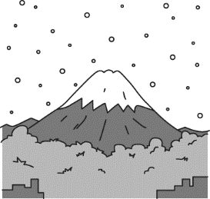(Ｂ) 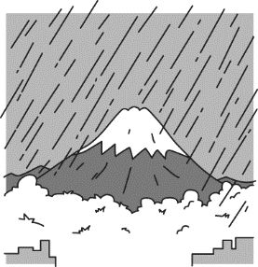(Ｃ) 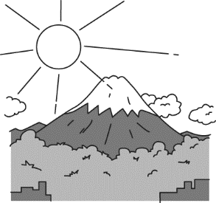
- （ ）(Ａ) 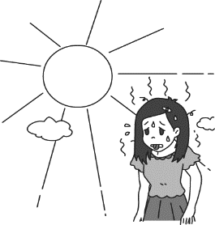(Ｂ) 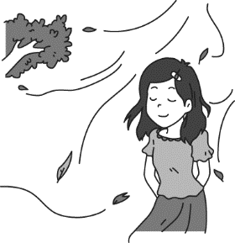(Ｃ) 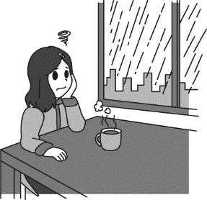
- （ ）(Ａ) 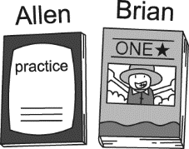(Ｂ) 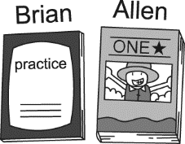(Ｃ) 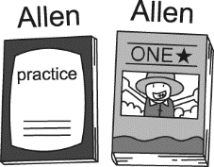
- （ ）(Ａ) 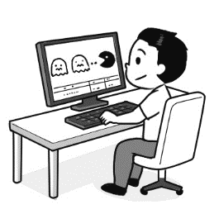(Ｂ) 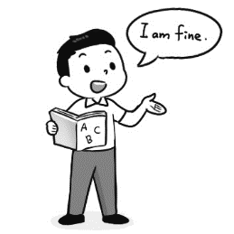(Ｃ) 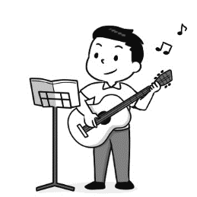
- （ ）(Ａ) 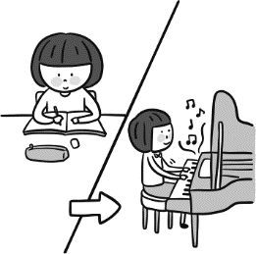(Ｂ) 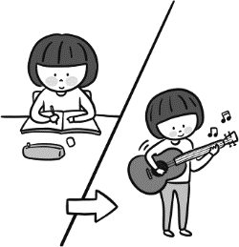(Ｃ) 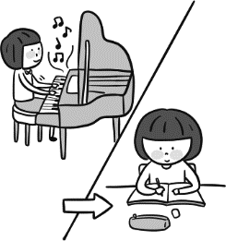

基本問答：根據聽到的內容，選出一個最適合的回應或最適合的問句。(每題2分)
- （ ）(Ａ) There are so many things on the table. (Ｂ) It is Mary’s.
(Ｃ) I need to buy a pen.
- （ ）(Ａ) We went jogging together last weekend. (Ｂ) I visited him once a week.
(Ｃ) I sent some comic books to him.
- （ ）(Ａ) Sorry. You have the wrong number. (Ｂ) Yes, I am Linda.
(Ｃ) I spoke to her five minutes ago.
- （ ）(Ａ) We have to sing a song together.
(Ｂ) I baked a cake and bought some drinks and food.
(Ｃ) I did my homework after the party.
- （ ）(Ａ) I was in the bathroom when you came. (Ｂ) I didn’t visit my uncle last night.
(Ｃ) I went shopping last night.

言談理解：根據聽到的內容，選出一個最適合的答案。(每題2分)
- （ ）(Ａ) Go to the beach. (Ｂ) Go mountain climbing. (Ｃ) Stay at home.
- （ ）(Ａ) It is rainy. (Ｂ) It is sunny. (Ｃ) It is snowy.
- （ ）(Ａ) The man had the wrong number. (Ｂ) The woman wanted to talk to Jason.
(Ｃ) Jason wasn’t in the office.
- （ ）(Ａ) Their math teacher. (Ｂ) Their favorite subjects.
(Ｃ) Their favorite sports.
- （ ）(Ａ) He likes to go shopping. (Ｂ) He likes to play basketball.
(Ｃ) He likes to go to a coffee shop.
PART 2: Choice(每題2分)
16. ( ) A man said “ go die” to me and I was so mad. But _____ he meant “good day.”
(A) however (B) and then (C) as soon as (D) in fact
17. ( ) A: That’s a lovely pink snowboard. _____ is it? B: It’s mine.
(A) Who (B) Who’s (C) Whose (D) How
18. ( ) I can’t _____ because all the clubs are interesting.
(A) make up my mind (B) pull my leg (C) hold on (D) look for
19. ( ) A: I like computer science. B: So when I heard about the video game design club , I _____ you.
(A) heard of (B) thought of (C) hear of (D) think of
20. ( ) I _____ for the water sports club after Shin told me about it.
(A) talked about (B) signed up (C) checked out (D) hold on
21. ( ) Our lessons are easy. They _____ difficult _____, and our teachers teach in a fun way.
(A) aren’t , at all (B) don’t , at all (C) aren’t , any more (D) don’t , anymore
22. ( ) Every year, we take two students _____ London Game Festival for free.
(A) on a trip to (B) on a trip (C) travel to (D) travel
23. ( ) A: What did he do before he _____ for the food company?
B: He was a clerk at an ice cream shop.
(A) works (B) worked (C) is working (D) can work
24. ( ) Ben’s cellphone is different from _____. _____ cellphone is white and his is red.
(A) hers, Her (B) hers, Hers (C) her, Her (D) her, Hers
25. ( ) A:________. B: It was great. I visited my aunt in India.
(A) What was the weather like in India?
(B) How was your trip to Australia?
(C) How was the weather in India?
(D) How was your summer vacation?
(26-30)
Winnie and Michael are talking about the clubs at school.
W: The school has a long _26._________ of clubs. They look very _27._________.
M: Yeah. What club do you want to _28._________?
W: I want to join the debate, speech, environment, and foreign language clubs.
M: Wow! That’s a lot! Do you have _29._________ time to do all of those?
W: I don’t know. I’ll probably just join one or two.? 30.____________________________.
M: I want to join the guitar club and maybe the anime or science club.
W: What? You don’t want to join the chess club? You love chess.
M: No. I don’t play chess anymore.
26. ( ) (A) list (B) line (C) numbers (D) names
27. ( ) (A) kind (B) heavy (C) sunny (D) interesting
28. ( ) (A) meet (B) join (C) talk (D) play
29. ( ) (A) enough (B) little (C) many (D) great
30. ( ) (A) How about you? (B) I don’t know. (C) Nice to meet you. (D) Good idea.

(31-35)
(Making a phone call)
A: Hello, may I speak to Sue?
B: _31._________. Who’s calling?
A: _32._________. Can we go to the library after school to prepare for the test tomorrow?
B: But the math teacher ask me to do my math homework in his office after school.
A: We can go to the library _33._________ you do your math homework.
B: What time will we leave the library? My favorite TV show is on at 9:00 p.m.
A: We can go home _34._________ the TV show start.
B: Can I think about it and _35._________ ?
A: Sure. Talk to you later.

31. ( ) (A) This is she. (B) I am. (C) She’s not here. (D) Is Sue there?
32. ( ) (A) James speaking. (B) Who is this? (C) Hold on. (D) I’m sorry.
33. ( ) (A) before (B) after (C) because (D) so
34. ( ) (A) before (B) after (C) because (D) so
35. ( ) (A) you have the wrong number (B) see you later (C) call back later (D) sorry for that

(36-39)
Dear Karen,  Hello from Australia. So happy to meet you at the website, Postcrossing. How do you think the weather is in Australia? Australia is big, and it is in the opposite hemisphere to Taiwan. So when it is in summer in Taiwan, it is winter in Australia.  Summer in the north of Australia is hot and humid. In the middle of Australia is hot and dry. It can be as hot as up to 50°C. In the south of Australia is also hot and dry, or humid if it is close to the beach.  Autumn in the south of Australia the leaves turn red and yellow. In the north, most trees are evergreen. In the south, the temperature starts to become cool.  Winter in northern Australia only gets down to 25°C, it is mostly sunny, and is the dry season. Winter in the middle , the temperature can can go from -5°C at night to 24°C in the day. In the south of Australia gets to -3°C at night but around 15°C in the day. Some mountains in southern Australia have snow, and you can even go skiing.  My friend, Shengjong, always said “Spring is the season of flowers in Australia.” And crazy birds will attack you to protect their babies.  Hope you will visit Australia someday.  Best wishes,  Monique  hemisphere 半球 north北部 humid 潮濕 middle中間  south南部 evergreen常綠 temperature溫度 skiing滑雪 attack攻擊 protect保護 | 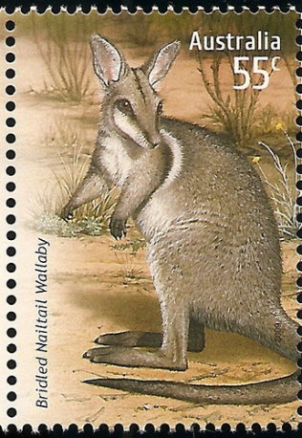  Karen Ko  No.101, Sanduo Rd.,  New Taipei City  Taiwan
36. ( ) What is the meaning of the word “opposite?” (A) the same (B) different (C) dry (D) humid
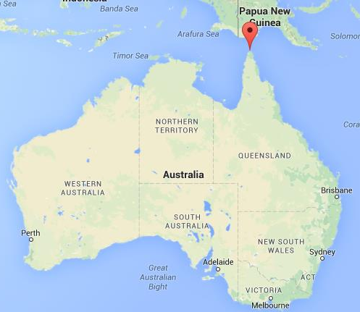
37. ( ) What is the weather like in Cape York in Winter?
( Please Look at the picture on the right.)
(A) rainy (B) warm (C) snowy (D) cold
38. ( ) What is the postcard mainly about?
- The weather in Australia.
- The trees in Australia.
- The rainy season and dry season in Australia.
- Compare the weather is Australia and Taiwan.
39. ( ) Which is correct?
(A) The weather in Australia is the same as the weather in Taiwan.
(B) The trees are evergreen in south of Australia.
(C) Summer is the dry season in the northern Australia.
(D) Monique wrote the postcard to Karen.

(40-43)
Queen Elizabeth II died at her castle in Scotland at the age of 96. At Buckingham Palace in London, people began crying when they hear of her death. She had ruled England for 70 years. The Queen’s health had been getting worse over the last few months, and she died peacefully. Her son, King Charles III, was very sad.
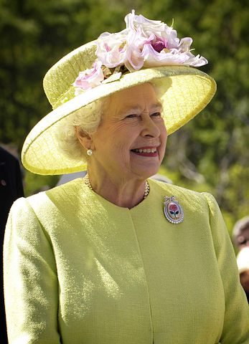
Queen Elizabeth had lived through interesting times as a ruler. She was queen during a lot of social change: from the end of the British Empire, the UK became a modern country and many things changed such as the television and the internet. She became a modern queen who would often talk to common people. She worked hard her whole life. Traveling was an important part of her job; the Queen travelled to 117 countries in 70 years. In fact, she traveled enough to make 42 journeys around the Earth.

Castle 城堡 rule統治 peacefully平靜的 ruler統治者 social社會
Empire帝國 modern現代的 whole整個的 Travel旅遊 important重要的 journey旅程
40. ( ) Where did Queen Elizabeth II die?
(A) At Buckingham Palace. (B) In London. (C) In Scotland. (D) We don’t know.
41. ( ) What does the sentence “Queen Elizabeth had lived through interesting times as a ruler” mean?
(A) The UK changed from the British Empire to a modern country.
(B) Queen Elizabeth II often talked to common people.
(C) Queen Elizabeth II worked hard her whole life.
(D) Queen Elizabeth II travelled to 117 countries in 70 years.
42. ( ) What is the best title of the article?
(A) The Modern England. (B) Queen Elizabeth II & King Charles III
(C) Buckingham Palace. (D) The ruler of England, Queen Elizabeth II
43. ( ) Which is true?
(A) Queen Elizabeth II died at 70 years old.
(B) Queen Elizabeth II talked to her people a lot.
(C) Queen Elizabeth II tripped to 70 different countries.
(D) Queen Elizabeth II’s travel distance was enough to make 70 journeys around the Earth.
--------------------------------------------------------------------------------------------------------------------------------------------------
新北市立三多國民中學111學年度第1學期 第1次段考 八年級 英語科手寫試題
班級： 座號： 姓名：

I. 字彙：(每題1分)
1. Erin can s k English because her father is an Australian.
2. Allie: What's your favorite school s t?
Tyler: Art.
3. My aunt designs computer games. She is a game e eer.
4. Ryan was a teacher before; he t t math at a high school.
5. Kate has too much homework. She can't f sh it before ten.
II. 翻譯：(每格1分)
1. A: 你為何穿著綠色的夾克?你討厭那個顏色。
B: 我的夾克不夠保暖，所以我姑姑給我他的厚外套。
A: Why were you __________ a green jacket? You __________ that color.
B: My Jacket was not warm enough, so my aunt __________ her __________ jacket to me.

2. 店員對我說：「餅乾和熱巧克力，你的餐點馬上來。」多奇怪啊!
The clerk said to me, “Bikkies and hot chokkie, your __________ is coming __________ up.”
__________ __________.
III. 依提示造句：(每句3分，請老師分段給分)
1. Can you buy me some milk? (請加入介係詞改寫句子)
_____________________________________________________________________________
2. Kyle looked around the room at 3:15.
Kyle saw a soccer ball on the bed at 3:15.（ 用When置於句首合併）
_____________________________________________________________________________
新北市立三多國民中學111學年度第1學期 第1次段考 8年級 英語科解答卷
班級： 座號： 姓名：

1 | 2 | 3 | 4 | 5 | 6 | 7 | 8 | 9 | 10
A | B | B | A | A | B | C | A | B | A
11 | 12 | 13 | 14 | 15 | 16 | 17 | 18 | 19 | 20
C | C | A | B | C | D | C | A | B | B
21 | 22 | 23 | 24 | 25 | 26 | 27 | 28 | 29 | 30
A | A | B | A | D | A | D | B | A | A
31 | 32 | 33 | 34 | 35 | 36 | 37 | 38 | 39 | 40
A | A | B | A | C | B | B | A | D | C
41 | 42 | 43
A | D | B

辨識句意：根據聽到的內容，選出符合描述的圖片或符合圖片的描述。
- （ ）錄音稿：It snows a lot in Japan in winter.

- （ ）錄音稿：W: My favorite season is fall because it is cool but very comfortable.
- 錄音稿：The workbook is Brian’s, and the comic book is Allen’s.
- 錄音稿：M: I joined the video game design club last week.
- 錄音稿：Amy played the piano after doing her homework last night.

基本問答：根據聽到的內容，選出一個最適合的回應或最適合的問句。
- （ ）錄音稿：Whose pen is it on the table?

- （ ）錄音稿：What did you send to your cousin last weekend?

- （ ）錄音稿：May I speak to Linda?

- （ ）錄音稿：What did you do before your birthday party?

- （ ）錄音稿：Where were you when I came to your place last night?

言談理解：根據聽到的內容，選出一個最適合的答案。
- （ ）錄音稿：W: It’s hot. I hate the hot days in Taiwan.
M: Me too. So what do you usually do on hot days here?
W: I don’t like to go outside. I usually stay at home.
M: Me, too.
Q: What do the man and the woman usually do on hot days in Taiwan?

- （ ）錄音稿：W: Hi, Sam. How’s your holiday in Toronto? Is it hot there?
M: Not really. It is so cold in Toronto. Most of the time, I stay indoors with my friends.
W: So does it snow a lot there?
M: Yes, it does. I seldom see snow in Taiwan, so it is very interesting to me.
W: Cool.
Q: What’s the weather like in Toronto now?

- （ ）錄音稿：M: Hi, can I speak to Jason?
W: Oh, sorry! You have the wrong number.
M: Is it 3350990?
W: No, it is 3358900.
M: Oh, I am so sorry!
Q: What happened in the talk?

- （ ）錄音稿：M: PE is my favorite subject. How about you, Vivian?
W: Not me. Math is my favorite.
M: No way! I hate math because I always get bad grades on it.
W: Maybe you can ask me for help next time.
Q: What are the man and the woman talking about?

- （ ）錄音稿：W: Mike, what do you like to do when you have time?
M: I like to read in the coffee shop. I enjoy a cup of coffee and read there. How about you?
W: I like to go shopping with my friends.
Q: What does Mike like to do in his free time?

