新北市立三多國民中學110學年度第2學期 第2次段考 七年級 英語科試題
班級： 座號： 姓名：

- Listening (1-10題，每題1分。11-15題，每題2分)

辨識句意：根據聽到的內容，選出符合描述的圖片或符合圖片的描述。
- （ ）(Ａ) 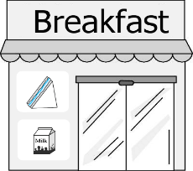 (Ｂ) 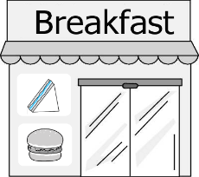 (Ｃ) 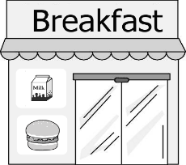
- （ ）(Ａ) 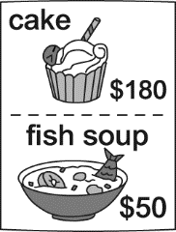 (Ｂ) 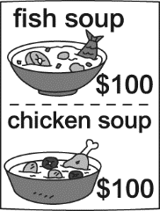 (Ｃ) 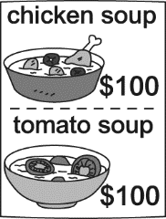
- （ ）(Ａ) 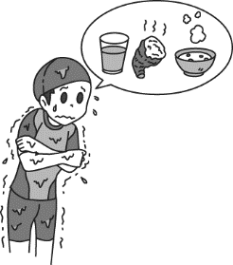 (Ｂ) 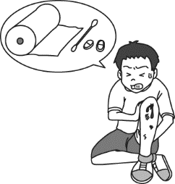 (Ｃ) 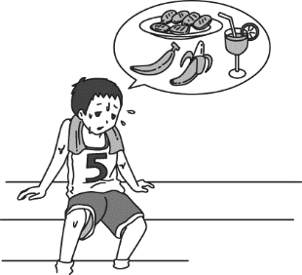
- （ ）(Ａ) 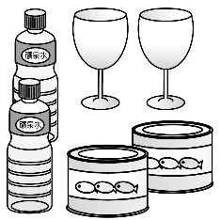 (Ｂ) 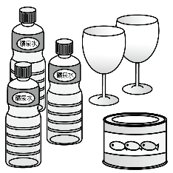 (Ｃ) 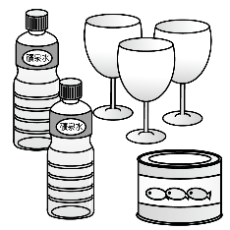
- （ ）(Ａ) 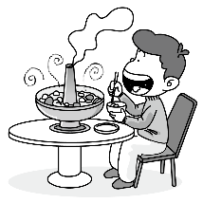 (Ｂ) 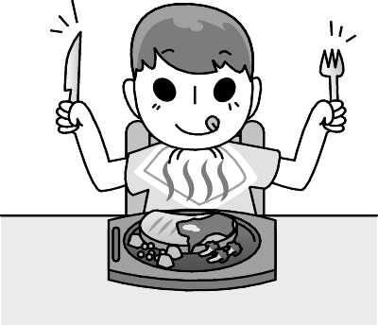 (Ｃ) 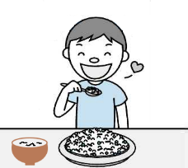

基本問答：根據聽到的內容，選出一個最適合的回應或最適合的問句。
- （ ）(Ａ) Great! It’s very yummy. (Ｂ) It is three hundred and fifty dollars.
(Ｃ) I don’t like the music there.
- （ ）(Ａ) She sells hot dogs and orange juice. (Ｂ) There is a lot of food at the bar.
(Ｃ) It’s a very great snack bar.
- （ ）(Ａ) Yes, I want to drink two bottles of water. (Ｂ) I’m very hungry now.
(Ｃ) Yes, I am very full.
- （ ）(Ａ) She needs five bottle. (Ｂ) Maybe three or four glasses. (Ｃ) She needs five.
- （ ）(Ａ) No, thanks. I don’t drink coffee. (Ｂ) Yes, that’s a new blender.
(Ｃ) Sure! Oh, it’s really yummy.

言談理解：根據聽到的內容，選出一個最適合的答案。
- （ ）(Ａ) Mom likes American food. (Ｂ) Mom wants to go to Lee’s Kitchen.
(Ｃ) Mom wants to go to Cheng’s Restaurant.
- （ ）(Ａ) A sandwich. (Ｂ) A rice ball. (Ｃ) Noodles.
- （ ）(Ａ) NT$120. (Ｂ) NT$130. (Ｃ) NT$140.
- （ ）(Ａ) The man eats rice every day. (Ｂ) The woman eats rice every day.
(Ｃ) The man cooks rice for the woman.
- （ ）(Ａ) At a tea shop. (Ｂ) At a toy shop. (Ｃ) At a green house.

- Choice (16-48，每題2分)
- ( ) I like the _____ part of the book. It is a happy ending(結局) . (A) first (B) second (C) last (D) third
- ( ) On Halloween, children always say “ Trick or ______.” (A) treat (B) trouble (C) chocolate (D) rice
- ( ) It’s bad to have night ____ before sleep. You may get fat. (A) water (B) snakes (C) snacks (D) soup
- ( ) I don’t need _____ sugar in my coffee. Just _____.
(A) many, much (B) much, a little (C) many, a lot (D) much, much
- ( ) ______ coffee are there in the fridge?
(A) How much (B) How many (C) How many cans (D) How many cans of
- ( ) A: Can you get me _______ from the store? B:All right.
(A) a bottle (B) a bottle of (C) a bottle milk (D) a bottle of milk
- ( ) I need some _____. I am thirsty. (A) sandwiches (B) hamburgers (C) juice (D) candy
- ( ) ______ do you like, RPG (Role-playing games) or AVG (Adventure games) ?
(A) What (B) Which (C) How much (D) How many
- ( ) A: How do you like the painting, The Sunflowers? B: ________. (A) It’s a painting by Milo.
(B) I like it! It’s very beautiful. (C) Who are these flowers for? (D) How much are these flowers?
- ( ) One slice of pizza is not enough for me. Can I have _____ slice of pizza?
(A) another (B) little (C) first (D) last
(晨間英聽)
- ( ) What do people or students do from Monday to Friday?
(A) They go to work or go to school. (B) They go out with their friends.
(C) They go to the museum. (D) They go to a coffee shop.
- ( ) On which festival do people in Taiwan usually eat “Zongzi(粽子)”?
(A) Easter (B) Christmas (C) Lantern Festival (D) Dragon Boat Festival
- ( ) Americans celebrate on the fourth Thursday of November.
(A) Easter (B) Thanksgiving (C) Christmas (D) New Year
- ( ) Which of the following is an appetizer?
(A) steak with side dishes (B) chicken hamburger (C) apple pie (D) fruit salad
- ( ) What does “yucky” mean in the chant?
(A) yummy (B) delicious (C) mouth-watering (D) disgusting
(31-36)
(In MacDonald.)
Clerk： 31.
Karen：Hello, may I have a double cheeseburger, please?
Clerk：With everything on it?
Karen：That sounds(聽起來) great.
Clerk：Do you want fries with your order?
Karen：May I get a large 32. , please?
Clerk：Do you want some 33. ?
Karen：Please get me a medium Coke.
Clerk：Would you like anything else?
Karen：No, thank you. That's it. 34. are they?
Clerk：No problem. Three hundred NT dollars. 35. ?
Karen：Because of covid 19, we don’t eat here. We have dinner at home.
Clerk： 36. .
Karen：Thanks a lot. Keep the change(零錢).
- ( ) Which is “False(錯誤的)”? (A) What can I get for you? (B) May I help you?
(C) That’s sweet of you. (D) How may I help you?
- ( ) (A) one (B) ones (C) it (D) that
- ( ) (A) drinks (B) snacks (C) popcorn (D) hot dogs
- ( ) (A) Which (B) What (C) How many (D) How much
- ( ) (A) It’s a work of art. (B) For here or to go? (C) What’s up? (D) Come on in.
- ( ) Which is “False(錯誤的)”? (A) Here you are. (B) Here you go. (C) My treat. (D) Here it is.

- Reading
(37-40)
Dear Karen,
I know you have on-line classes this week. Your teacher wants you to be on-line from 8:20 to 15:55. After class, please buy two bags of cookies, a bottle of cola, a slice of pizza and two pieces of cake for me after your on-line classes. I am so busy at work. Don’t buy bananas and coffee. James bought (購買) them yesterday(昨天) at the supermarket. By the way, do you want some hamburgers and fried chicken for dinner? You can buy them on your way home. Mom
May 2 Wed.
Supermarket
(ONLY on May 2! Everyone can get one drink – For Free)
(Every Tuesday：Buy 1 Coffee Get 1 Coffee Free.)
item | price | item | price | item | price
 | 35 / bottle | 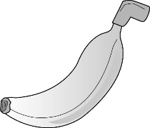 | 20 | 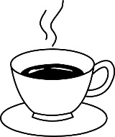 | 80 / cup
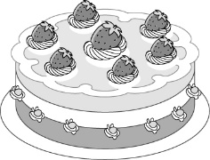 | 60 / piece  200/  one | 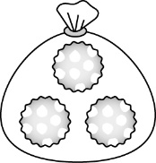 | 100 / bag | 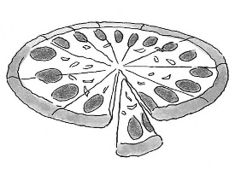 |  | 50/  Slice  300/  one

37. ( ) What does Karen need to buy?
(A) Fried chicken. (B) Coffee. (C) Pizza. (D) A hamburger.
38. ( ) Karen buys the things as (如同) Mom says. How much are they?
(A)370. (B) 405. (C) 900. (D) 935.
39. ( ) James bought (買) 2 bananas and 2 cups of coffee. How much are they?
(A) 40. (B) 120. (C) 140. (D) 200.
40. ( ) Which is true?
(A) Karen bought bananas yesterday. (B) Mom likes to have pizza for dinner.
(C) James wants to eat something. (D) Karen is a student.

(41-44)

◆_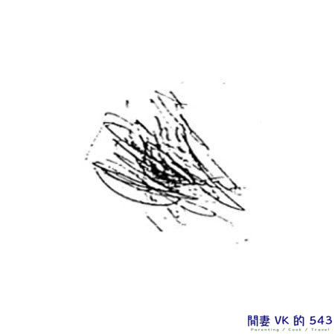 _

Scones are an English afternoon tea snack. They’re yummy. People usually have them with jam and butter. Scones have a unique taste(味道). They are traditionally made with flour, butter, sugar and milk. Where is the recipe from? Scones may come from Scotland in the early 1500s. The first one is by a Scottish poet(詩人) in 1513.

◆How to make perfect scones.

Step 1: In a large bowl, mix the butter into the flour. Put a little sugar and salt. Put all the baking powder in.

Step 2: Make a well(井) in the center(中央) of the step 1. Mix it until the dough(麵團) comes together.

Step 3: Shape the dough into a round shape about 3 - 4 cm thick.
Step 4: Brush with milk.
Step 5: Cut it into 8 parts. Each part is in the shape of a triangle.
Step 6: Bake(烘焙) for 15 minutes until golden and cooked. Serve with jam and butter.

41. ( ) What does the word “them” mean from the first line?
(A) English afternoon tea. (B) Scones. (C) Jam and butter. (D) English.
42. ( ) What do we need?
  - (B)
- 2 cups of marshmallows
- 3 teaspoons of baking powder
- 1 teaspoon of salt and sugar
- 1/3 cup of cold butter
- 2/3 cup of milk
- 2 cups of flour
- 3 teaspoons of baking powder
- 1 teaspoon of salt and sugar
- 1/3 cup of cold butter
- 2/3 cup of milk

(C) (D)
- 2 boxes of chocolate
- 3 teaspoons of baking powder
- 1 teaspoon of salt and sugar
- 1/3 cup of cold butter
- 2/3 cup of milk
- 2 cups of flour
- 3 teaspoons of baking powder
- 1 teaspoon of salt and sugar
- 1/3 cup of cold butter
- 1 bag of crackers

43. ( ) What does it look like in step 5.
 | (B) | (C) | (D)
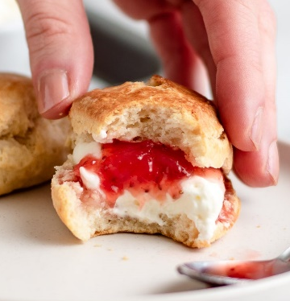 | 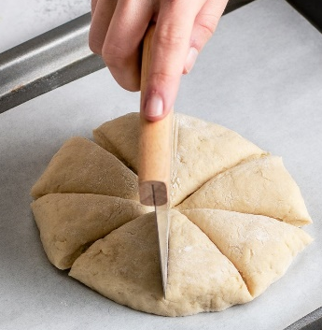 | 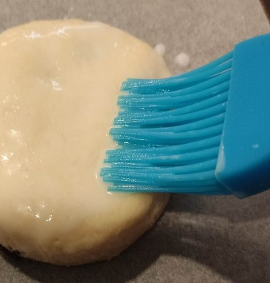 | 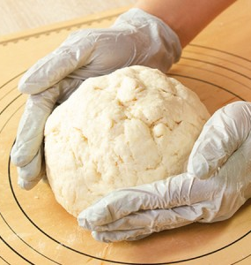
44. ( ) A kid drew(畫) on the first line ◆_ . It is the title(標題) of the paragraph(段落).
What is it?
- What do we need? (B) What do we get?
(C) Who makes the first scone? (D) What do we know about scones?
(45-48)
Karen and her class have to do a report about “Easter”.
Here is a website(網頁). Please take a look and answer the questions.

Christian(基督教) tradition(傳統) information(資訊)
Easter is the Christian holiday of the resurrection of Jesus Christ. They believe Jesus Christ died and then came back to life after three days. It is the oldest tradition. It is also the most important date for Christian. Here are some information to help you know more.
What else do you want to know?
What
do people do
on Easter?
When
is Easter?
45. ( ) Karen clicks(點擊) one of the square and gets the following information. Which is true?
The date of Easter changes every year. This is because Easter falls on the first Sunday after the full moon. However, this always falls on or between 22nd March and 25th April.
- Karen clicks the square(四方形) of “What do people do on Easter?”
- Easter falls on the first Sunday before the full moon.
- Easter is always in March or April.
- The date of Easter is the same every year.
46. ( ) Karen clicks the square of “What do people do on Easter?” According(依據) to what you know about Easter, which can’t she find from the website?
- Families often get together on this day, and they go to church in the morning.
- Kids paint eggs in beautiful colors. Each Easter egg is unique.
- Kids roll Easter eggs or go on an Easter egg hunt.
- They place Christmas gifts under Christmas tree.
47. ( ) Karen wants to know the history(歷史) about Easter. Which square does she click?
(A) When is Easter?
(B) What do people do on Easter?
(C) What else do you want to know?
(D) She can’t find it from the website.
48. ( ) Which is not true?
(A) The word “resurrection” means coming back to life.
(B) Easter is the oldest Christian holiday.
(C) Easter falls on different date every year.
(D) Easter is not an important holiday for Christian.

-----------------------------------------------------------------------------------------------------------------------------------
新北市立三多國民中學110學年度第2學期 第2次段考 七年級 英語科試題手寫卷
班級： 座號： 姓名：

- 翻譯：(依提示翻譯) (1 格1分，共14分)
- 在畫裡，一些人正在咖啡廳喝飲料。
In the __________, some people are __________ __________ at the coffee shop.
- 這兩個部分，亮黃色的咖啡廳和深藍色的夜空，搭配得十分完美。
The two __________, the __________ yellow coffee shop and the __________ blue night __________, are perfect __________.
- 我親戚在我家，而且今晚要吃大餐。
My __________ are here at my house, and there’s a big __________ __________.
- 在美國，巧克力棉花糖夾心餅很受小孩歡迎。
S’mores are __________ __________ __________ in the USA.

新北市立三多國民中學110學年度第2學期 第2次段考 七年級 英語科試題答案卷
班級： 座號： 姓名：

1 | 2 | 3 | 4 | 5 | 6 | 7 | 8 | 9 | 10
A | B | C | C | C | A | A | A | C | C
11 | 12 | 13 | 14 | 15 | 16 | 17 | 18 | 19 | 20
B | B | C | A | A | C | A | C | B | D
21 | 22 | 23 | 24 | 25 | 26 | 27 | 28 | 29 | 30
D | C | B | B | A | A | D | B | D | D
31 | 32 | 33 | 34 | 35 | 36 | 37 | 38 | 39 | 40
C | A | A | D | B | C | C | A | B | D
41 | 42 | 43 | 44 | 45 | 46 | 47 | 48 | 49 | 50
B | A | B | D | C | D | C | D

1.錄音稿：M: The breakfast shop sells fruit sandwiches and apple milk.
2.錄音稿：M: How much is the fish soup?
W: The fish soup is one hundred dollars. Do you want some?
3.錄音稿：B: I need some bananas, cookies and a glass of juice.
4.錄音稿：W: There are two bottles, three glasses, and one can.
5.錄音稿：M: Patrick is having a plate of fried rice and a bowl of soup.
6.錄音稿：How is the food at the Chinese restaurant?
7.錄音稿：What does your grandma sell at her restaurant?
8.錄音稿：Are you thirsty, Paul?
9.錄音稿：Mom is making an apple pie. How many apples does she need?
10.錄音稿：M: What’s that in your blender?
W: It’s chocolate milk shake. Do you want to try some?
11.錄音稿：M: Mom, which do you like, Chinese food or American food?
W: I like Chinese food.
M: Great! Which restaurant do you want to go to, Lee’s Kitchen or Cheng’s Restaurant?
W: Lee’s Kitchen. I like the sweet and sour fish.
M: Me too. Let’s go now.
Q: Which is true?
12.錄音稿：M: Do people in Taiwan have rice for breakfast?
W: Well, only some eat rice for breakfast. I have a rice ball and soy milk for breakfast. How about you?
M: I have a sandwich.
Q: What does the woman have for breakfast?
13錄音稿：Nancy is at a restaurant. She has a chicken sandwich, a fish sandwich, and some soup for dinner. The chicken sandwich is NT$45, the fish sandwich is NT$65, and the soup is only NT$30. Nancy is having a good time at the restaurant.
Q: How much is Nancy’s dinner?
14錄音稿：W: How many bowls of rice do you eat every day?
M: I eat three bowls of rice every day. How about you?
W: I don’t like rice. I don’t eat any.
Q: Which is true?
15錄音稿：M: How much is a glass of green tea?
W: It is twenty for one glass. Buy five, and you can get a sixth glass for free.
M: OK! I’ll buy five glasses.
Q: Where is the man?

